

SIMATS ENGINEERING

Saveetha Institute of Medical and Technical Sciences
Chennai- 602105

Student Name: Milan. A (192424377)
Course Code: DSA0216 Slot: B
Course Name: Computer Vision with OpenCV for Modern AI
Course Faculty: Dr S. Senthilvadivu & Dr. T Kumaragurubaran
Project Title: Aqua Vision: Image-Based Water Turbidity and Pollution Estimation System Using OpenCV
Module Photographs:

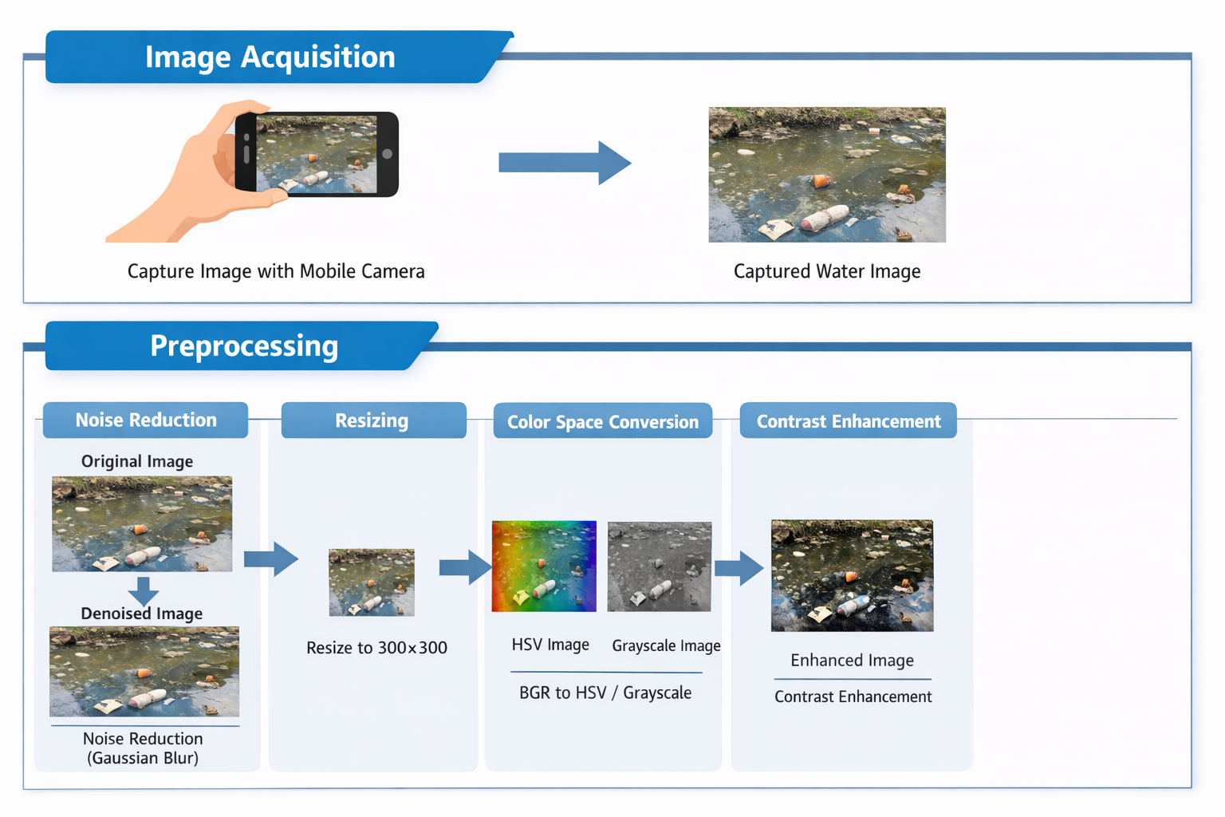
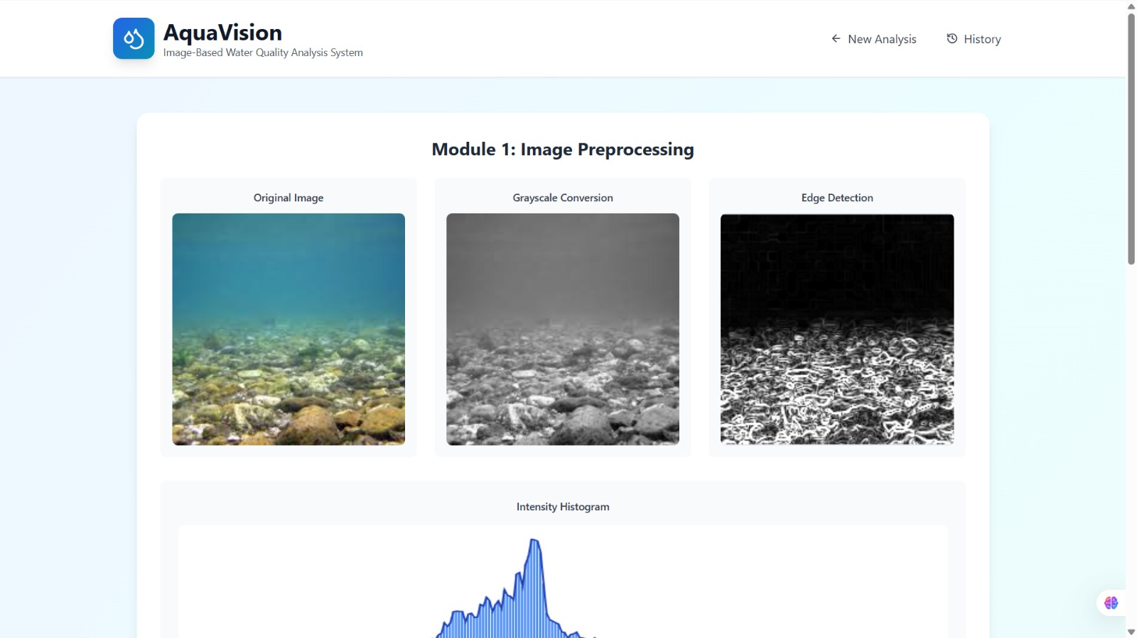
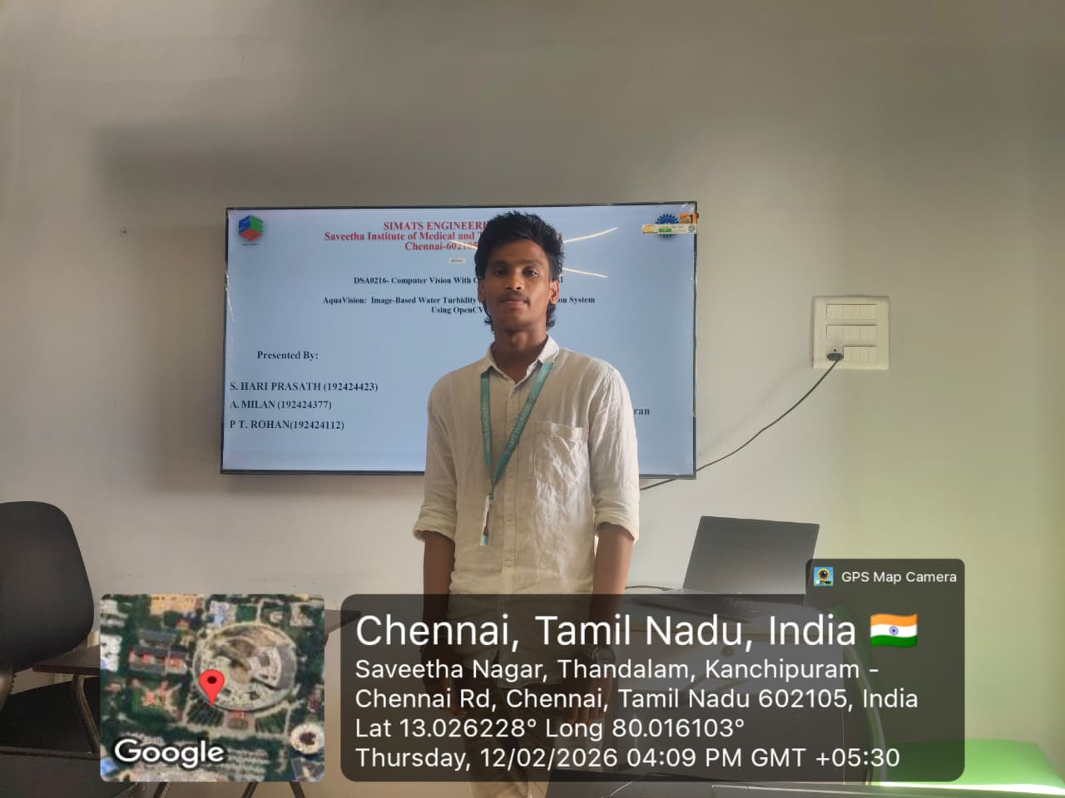

Project Description: Image Acquisition & Preprocessing
Aqua Vision begins with the Image Acquisition & Preprocessing module, the essential first step that captures high-quality water images and prepares them for accurate turbidity and pollution analysis. Using OpenCV, this module handles everything from grabbing photos via smartphone cameras, webcams setups to cleaning them up for downstream CNN classification and feature extraction. Designed for real-world use in Chennai's rivers, lakes, and coastal areas, it ensures reliable inputs even under tough conditions like glare, waves, or low light. his module is responsible for capturing clear and reliable images of water bodies such as rivers, lakes, ponds, or tanks using a digital camera or mobile camera. The quality of the final analysis depends on how well the images are collected and prepared. In this stage, the system captures real-time images under proper lighting conditions to avoid shadows and reflections. After capturing, the images are resized to a standard resolution for faster processing. The system also converts images from RGB to grayscale or HSV colour space to highlight important features related to turbidity and pollution. Contrast enhancement and normalization are performed to improve visibility of suspended particles.

Student Signature Guide Signature

